What we want in Newsletter:

- Immune boost Herbal Medicine
The immune system is your body’s natural defence system. It’s an intricate network of cells, tissues, and organs that band together to defend your body against invaders.

A Healthy lifestyle is the key to an efficient immune system. It is essential to eat plenty of nutritious organic foods, have sufficient sleep, do regular exercise, and have a positive attitude in dealing with stress. This helps in keeping peace of mind and a good digestive fire which in turn helps efficiently digest and eliminate the waste from our body.

Natural herbs offer immune stimulants that perform their work in a variety of ways. Some herbs increase the production and activity of macrophage cells (specialised immune cells sent to digest invaders). While others stimulate the production of defence substances such as interferons which protect non infected cells from viruses. Herbs can also enhance the production and function of T-cells. These are vital immune cells that kill viruses, fungi and certain bacteria.

Examples of Immune enhancing herbs include Ginseng, Guduchi Cats claw, Ashwagandha, Liquorice Astragalus, Echinacea Olive leaf, Garlic Shiitake, Reishi mushrooms and turmeric. These herbs enhance the body’s resistance to infection. Further, recent research has demonstrated that Beta-glucans from medicinal mushrooms such as Shiitake and Reishi can significantly improve blood cholesterol and enhance immunity by activating immune cells; Macrophages, Neutrophils, Basophils and Natural Killer cells.
We recommend that you boost your immunity by drinking a blend of immune boosting herbs 3 times a day
Book in with our Medical Herbalists to see how we can help you.
1-hour Consultation £80
½ hour Follow up session £4

- Promote lip fillers
Lip Augmentation is a cosmetic procedure that aims to give the mouth a more youthful and rejuvenated appearance. We achieve this by enhancing lip definition and increasing the volume of thin lips. Our aim is to enhance the natural shape of YOUR lips
Before
After
Before
After

Before
After

Before and after photos-
- Process of skin ageing and what we can treat with non-surgical cosmetic treatment

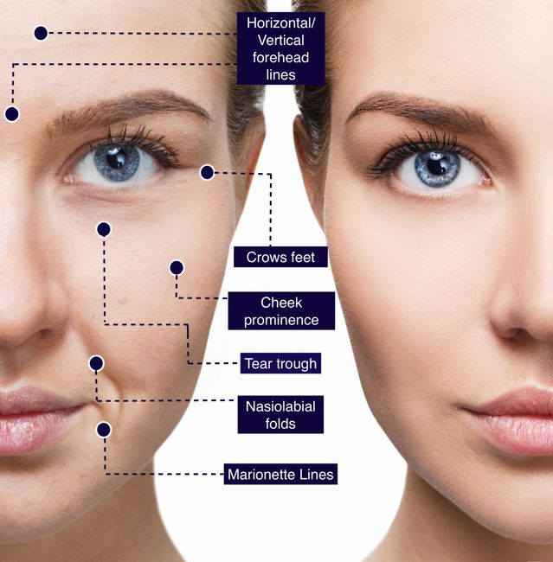
- Non-surgical treatment includes treatment with Hyaluronic acid based dermal fillers and anti-wrinkle injections (note: please book a free consultation with Dr Dhanak to see if anti-wrinkle injections would be beneficial to you)
- Hyaluronic acid (HA) is a naturally occurring carbohydrate found throughout the human body with its greatest concentration being found in the skin tissue. HA acts as the body’s natural ‘moisturiser’ which helps maintain the elasticity and firmness of the skin by hydrating collagen and elastin. As we age, the concentration of HA in the skin decreases giving rise to fine lines and wrinkles.

We offer bespoke consultations, listen to your concerns and agree on a treatment plan to achieve the best outcome for you

Dr Priyanka Dhanak
Dr Priyanka Dhanak BDS MFDS RCSEd, is a qualified dental surgeon and Harley street trained facial aesthetics clinician. Dr Dhanak is currently completing a year long training post in Oral & Maxillofacial surgery which has given her the ideal platform to enhance her surgical skills.

‘Facial aesthetics is an exciting field that I am passionate about! The health of my patients is my priority and my ethos is around providing natural, rejuvenating non-surgical cosmetic treatment alongside complimentary medicine patient care. At Visage Dermalogical clinic I am proud to work with a nutritional therapist and Obagi Abassador Skin care expert which allows my patients to achieve exactly this!’

PRESENT CODE 2021 AND GET £10 OFF FROM ANY AESTHETIC MEDICINE TREATMENT

